Chapter 2, Solution 67

(a) By current division,

i₀ = 5/(5 + 5) (2 mA) = 1 mA
V₀ = (4 kΩ) i₀ = 4 x 10³ x 10⁻³ = 4 V

- 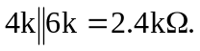 By current division,
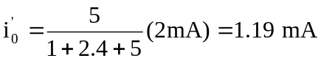
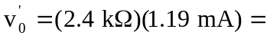 2.857 V

- % error = 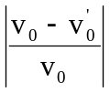 x 100% = 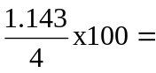28.57%
- 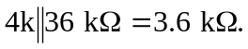 By current division,
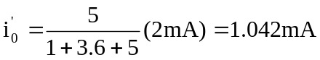
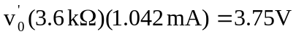
% error = 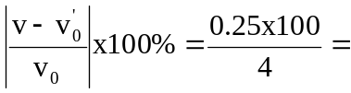6.25%

